I have used the commands like / and ~ to know the root
Directory and home directory.
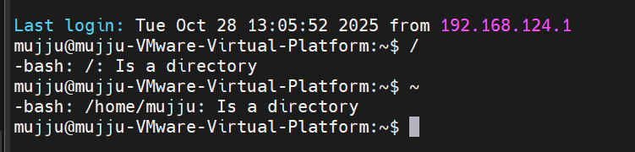

I have used the command ls to see the list of files and pwd to know the present working directory then used cd command to change the directory from mujju to desktop and used command cd .. to go one step back and cd ../.. to go two steps back then I used cd /to go to root directory and cd ~ command to go to home directory.

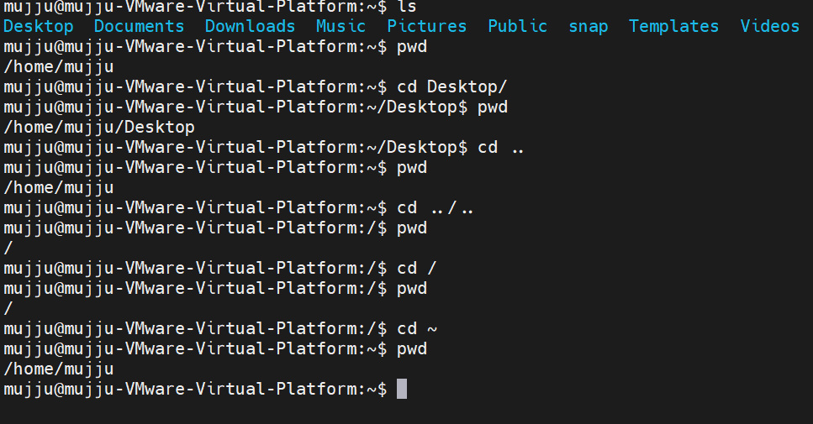

I have used the command pwd to know the present working directory and command ls to see the list of files and ll to see the long list of files then I have used command ls -ltr which shows the same output as ll and the command ls -a to see the hidden files.

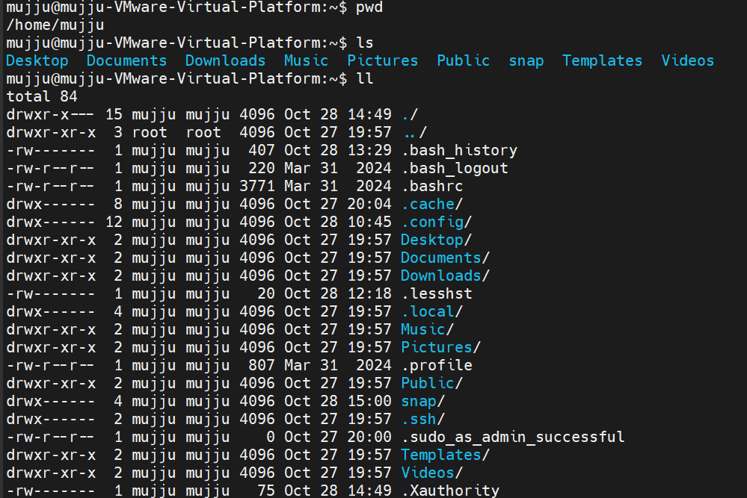

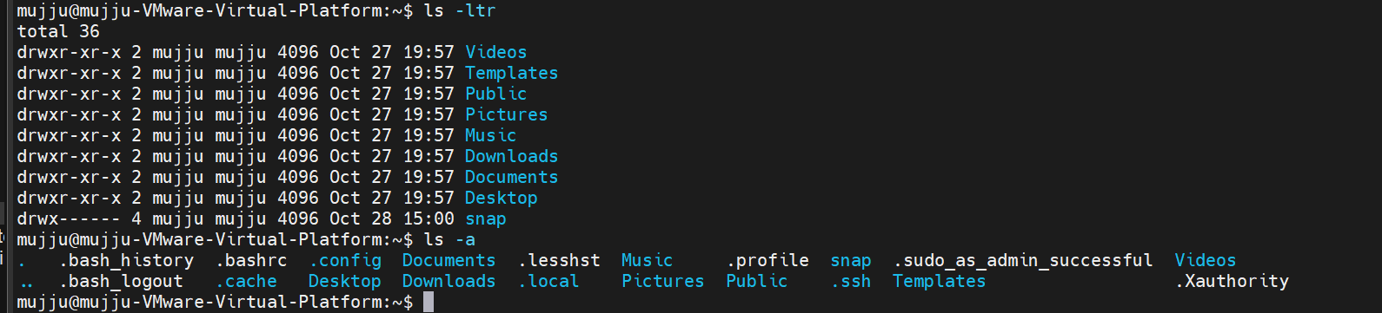

I have used ls command to see the list of files and created a directory named tahseen with mkdir command and then hidden the irectory with command mv directory name .directory name then unhided it with command mv .directory name directory name and created a directory of two words in one directory using underscore _ then deleted the directory with rm -rf directory name command
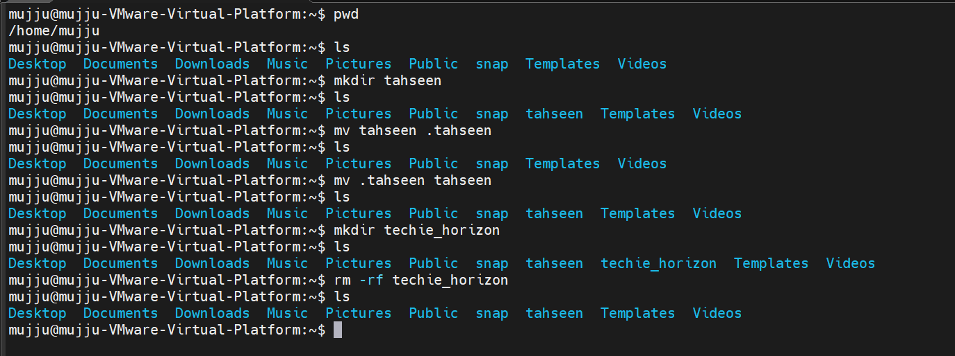

I created a directory using mkdir command and then changed the directory and then came one step back and moved the directory another location by using mv filename and location command.

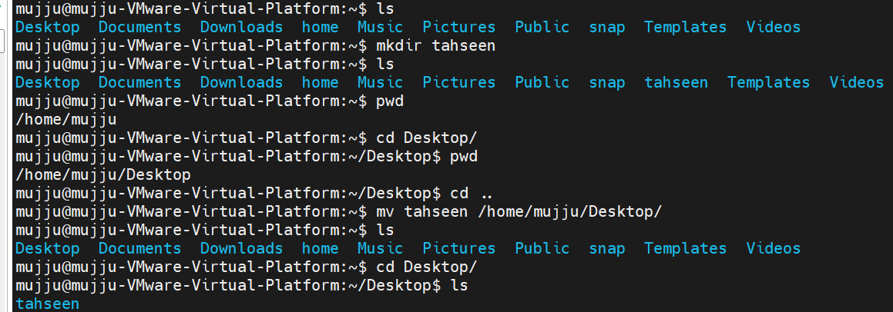

I have created a zero byte file by using touch file name command and added content by using vi editor and used I for inserting the content and saved it by using escape ,shift ,colon ,wq! Command and read the content by using cat file name command and after that I used another command vi filename command which creates a file and directly opens into editor to add content.
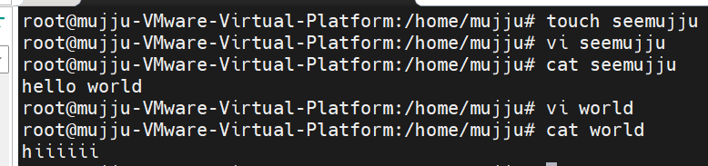

I ran the command history and got all the commands which shows all the history of commands I have used
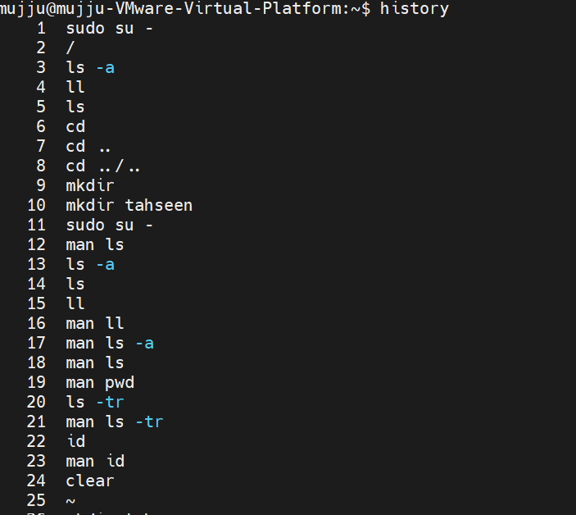

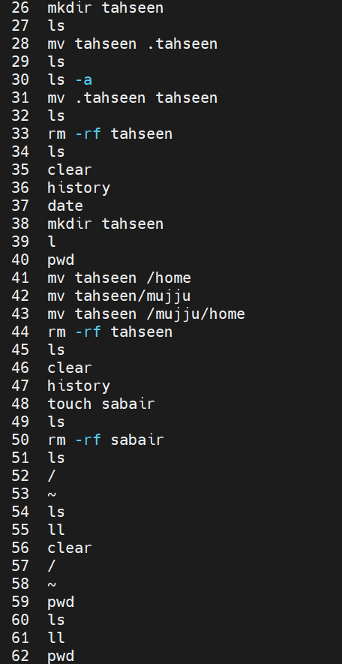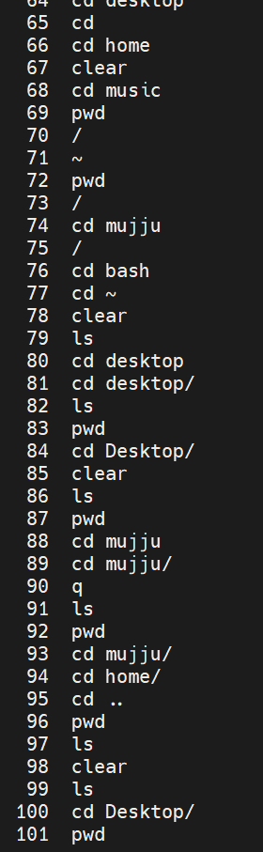
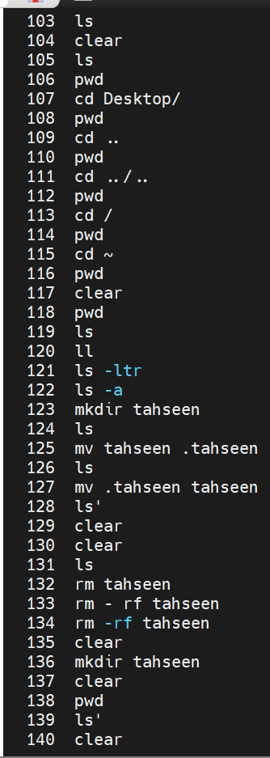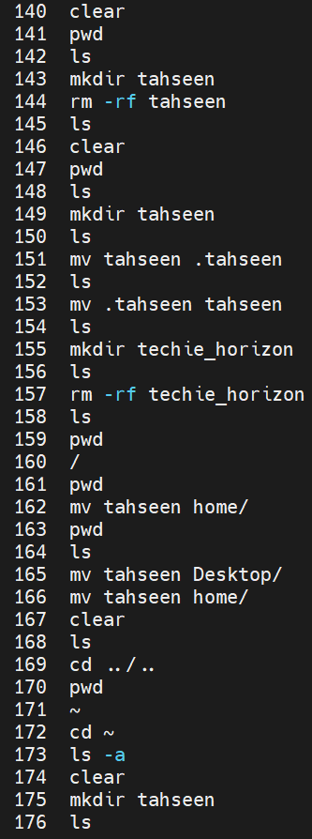

I have created a path d1 using mkdir -p d1 command and checked list ls command

